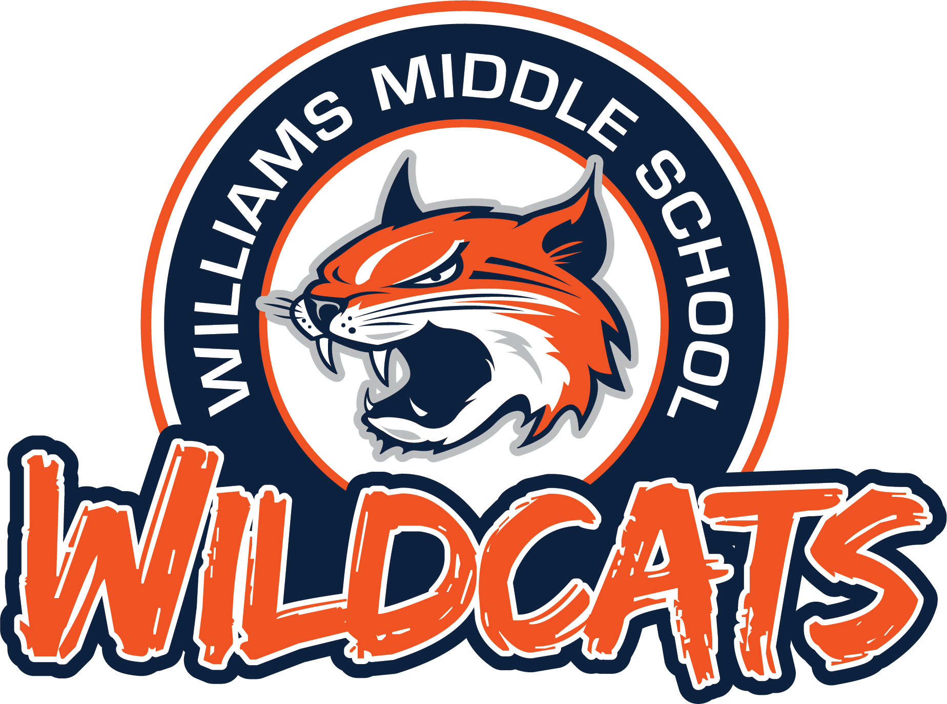

School Supply List
J.W. Williams Middle School
7th and 8th Grade
2023 - 2024

GENERAL SCHOOL SUPPLIES–REQUIRED DAILY

- Students will not be required to turn in the following items to teachers.
- Students are expected to keep necessary daily supplies in their backpacks and replenish them as needed.

#2 pencils (60) Expo Markers (4 count)
Colored Pencils (12 count) Highlighters (assorted colors)
Black or Blue Pens (2 pack) Notebook Paper
Glue Sticks (18 count) 3-Subject Spiral (7th English, 8th English)
Folder (Homework) or 3-Ring Binder Composition Notebooks (2-7th Science)
Earbuds (compatible w/ Chromebooks) Composition Notebooks (2-SS)
Water Bottle (for bottle filling stations)
Highly Recommended: Ti 84 CE Calculator (8th Algebra, Geometry, 8th Math, 7th Honors Math)
Students will turn in the following items:
7th Grade – 2 Boxes of Kleenex (Library)
7th Grade - 2 Bottles of Glue (Science)
8th Grade – 4 Count AAA Batteries (Math)
All Students - Hand Sanitizer (Library)
All Students - Paper Towel Roll (Science)

- Elective courses will provide specific supply lists at the beginning of the school year.
- Additional course-specific supplies may be needed throughout the school year for special projects.

